CareerWay - Value Proposition Canvas

1. Customer Segment
CareerWay is designed to help students explore and discover career paths through AI-driven guidance, gamification, and real-time opportunity tracking.
• High school students (Grades 9-12) who need guidance on career options.
• College students seeking internships, scholarships, and career growth.
• Parents and teachers who influence students’ career decisions.
• Ed-tech platforms and universities looking for career guidance tools.
• Job platforms and companies looking for early talent pipeline.

2. Customer Pains
Students, especially in Tier-2 and Tier-3 cities, face major challenges when choosing career paths:
• Limited Career Exposure: Many students only know about traditional careers (Engineering, Medicine, MBA).
•Lack of Guidance: No personalized or affordable career counseling options.
• Unawareness of Opportunities: Many students miss out on scholarships, internships, and career-building resources.
• Overwhelming Choices:Without structured guidance, students feel lost among too many options.
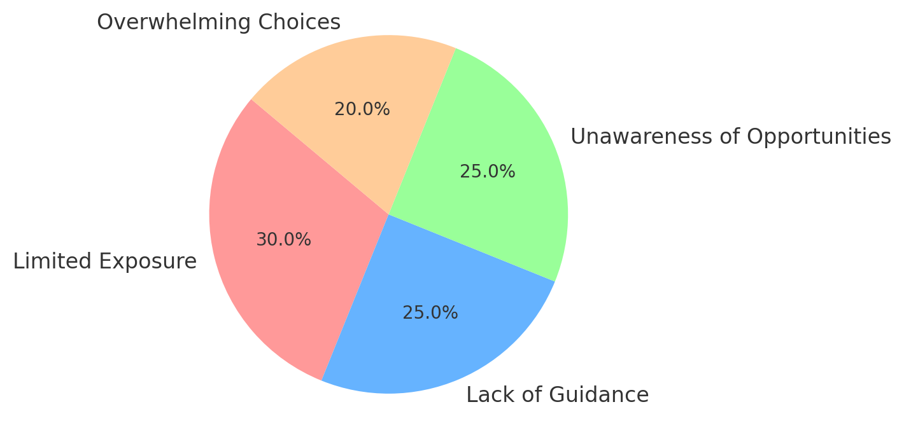
Pie Chart: Breakdown of Student Pain Points

3. CareerWay Gains & Solution
CareerWay addresses these problems by offering:
• AI-powered career chat – Understands student interests and recommends the best career paths.
• Career roadmap builder – Step-by-step guide on how to reach the chosen career.
• Scholarship & Internship aggregator – Helps students find real-time opportunities.
• Gamified career exploration – Career mini-games allow hands-on experience of different roles.
• Multi-language support– Expands accessibility to students in different regions.

